NITTE MEENAKSHI INSTITUTE OF TECHNOLOGY
(AN AUTONOMOUS INSTITUTION, AFFILIATED TO VISVESVARAYA TECHNOLOGICAL UNIVERSITY, BELGAUM, APPROVED BY AICTE & GOVT.OF KARNATAKA

DATA MINING (18CS54)
LA-2 REPORT
On
K-MEANS CLUSTERING ALGORITHM

Submitted in partial fulfilment of the requirement for the award of Degree of
Bachelor of Engineering
In
Computer Science and Engineering
Submitted by:
NAME  MEDHA M HEGDE  POTULA DIVYA  RAMANAPPAGARI TEJASREE | USN  1NT19CS110  1NT19CS137  1NT19CS152


Department of Computer Science and Engineering
2021-22

 | Nitte Meenakshi Institute of Technology  (AN AUTONOMOUS INSTITUTION AFFILIATED TO VISVESVARAYA TECHNOLOGICAL UNIVERSITY, BELGAUM)  PB No. 6429, Yelahanka, Bangalore 560-064, Karnataka  Telephone: 080- 22167800, 22167860  Fax: 080 - 22167805 | 
Department of Computer Science and Engineering

CERTIFICATE
This is to certify that the LA component titled “k-means clustering algorithm” is an authentic work carried out by Medha M Hegde (1NT19CS110), Potula Divya (1NT19CS137), Ramanappagari Tejasree (1NT19CS152) bonafide students of Nitte Meenakshi Institute of Technology, Bangalore in partial fulfilment for the award of the degree of Bachelor of Engineering in COMPUTER SCIENCE AND ENGINEERING of Visvesvaraya Technological University, Belagavi during the academic year 2021-2022.

Signature of the Guide |  | Signature of the HOD

DECLARATION
We hereby declare that

(i) This report does not contain text, graphics or tables copied and pasted from the Internet, unless specifically acknowledged, and the source being detailed in the report and in the References sections.
(ii) All corrections and suggestions indicated during the internal presentation have been incorporated in the report.
(iii) Content of the report has been checked for the plagiarism requirement.

NAME | USN | SIGNATURE
MEDHA M HEGDE | 1NT19CS110 | 
POTULA DIVYA | 1NT19CS137 | 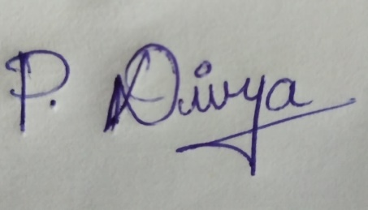
RAMANAPPAGARI TEJASREE | 1NT19CS152 | 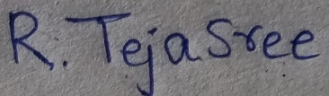

Date: 19/01/2022

ACKNOWLEDGEMENT

The satisfaction and euphoria that accompany the successful completion of any task would be incomplete without the mention of the people who made it possible, whose constant guidance and encouragement crowned our effort with success. I/we express my/our sincere gratitude to our Principal Dr. H. C. Nagaraj, Nitte Meenakshi Institute of Technology for providing facilities.
I/we wish to thank our HoD, Dr. Sarojadevi H for the support and encouragement for the project work. I/We also thank him for the invaluable guidance provided which has helped in the creation of a better technical report.
I/We thank Dr. Sujata Joshi, Associate Professor, CSE NMIT for the guidance and support given while doing this project work and preparing the report & presentation. I/We also thank all our friends, teaching and non-teaching staff at NMIT, Bangalore, for all the direct and indirect help provided in the completion of the presentation.

NAME | USN | SIGNATURE
MEDHA M HEGDE | 1NT19CS110
POTULA DIVYA | 1NT19CS137
RAMANAPPAGARI TEJASREE | 1NT19CS152

Date:19/01/2022

ABSTRACT

K-means is one of the most popular Unsupervised Machine Learning Algorithms Used for Solving Classification Problems. K Means segregates the unlabelled data into various groups, called clusters, based on having similar features, common patterns. It is an Iterative algorithm that divides a group of n datasets into k subgroups/clusters based on the similarity and their mean distance from the centroid of that particular subgroup.

- INTRODUCTION

  - MOTIVATION
The K-means clustering algorithm is Fast, robust and easier to understand. This can be used to confirm business assumptions about what types of groups exist or to identify unknown groups in complex data sets. It is also used in a variety of applications such as market segmentation, document clustering, image segmentation and image compression. Since this algorithm can be understood easily, it helps us in understanding clustering of large data sets as well. So, it fascinated us to go ahead with k means clustering algorithm.

  - PROBLEM DOMAIN
K-means Algorithm is an Iterative algorithm that divides a group of n datasets into k subgroups /clusters based on the similarity and their mean distance from the centroid of that particular subgroup/ formed. This algorithm can be applied on any domain containing smaller or larger datasets to be clustered or grouped for a classification. In k-means algorithm, we get a meaningful intuition of the structure of the data we’re dealing with. This can be used on the domain that can be solved using classification.

  - AIM AND OBJECTIVES

K-means algorithm is an iterative algorithm that tries to partition the dataset into K pre-defined distinct non-overlapping subgroups (clusters) where each data point belongs to only one group. It tries to make the intra-cluster data points as similar as possible while also keeping the clusters as different (far) as possible.

We have implemented K-means algorithm by constructing a 2D dataset with four distinct blobs and then use the k-means algorithm to observe the results as well as implemented on a randomly generated dataset. We have also implemented the Elbow Method to find optimal value for clusters. The elbow method helps to choose the optimum value of ‘k’ (number of clusters) by fitting the model with a range of values of ‘k’.

It makes the intra-cluster data points as similar as possible while also keeping the clusters as different as possible. The elbow method can also give the effective clulstering solutions.

- DATA SOURCE AND DATA QUALITY
  - DATASET USED
We have used a dataset consisting of few cities and the latitude, longitude, and language spoken in those regions for the elbow method. We also developed a program where random dataset is generated and clustering is performed.
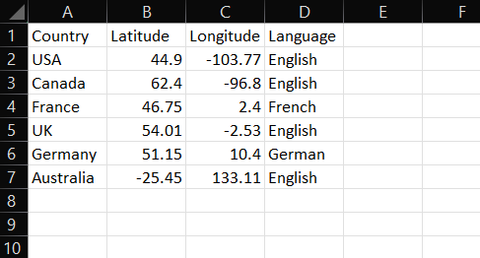
In the other case , the random data point set generation is used in order to combine the huge amount of data. Around five thousand data points are generated which can be successfully clustered in a effective way. The figure given below shows the five thousand random points.
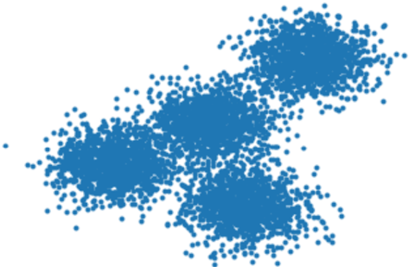
  - DATA PRE-PROCESSING
Data pre-processing is a process of preparing the raw data and making it suitable for a machine learning model.
There are various steps involved in the data processing. They are listed below.
The steps involved in this are:
- Getting the dataset
dataset = pd.read_csv("Countryclusters.csv")

- Importing the libraries
import pandas as pd
import matplotlib.pyplot as plt
import seaborn as sns
import random
import numpy as np
import matplotlib.pyplot as plt
from sklearn.cluster import KMeans
from sklearn.datasets import make_blobs

- METHODS AND MODELS

  - DATA MINING QUESTIONS
Question 1:
For both the randomly generated dataset and the given dataset, apply K-means algorithm and show the clustering graphically.
Question 2:
From the dataset, plot the variation within each cluster/WCSS vs K(number of clusters) and analyze the result.
Question 3:
What information can be inferred from the clusters formed?
Question 4:
Why is Elbow method used to find optimal number of clusteres?

  - DATA MINING ALGORITHM
An “algorithm” in machine learning is a procedure that is run on data to create a machine learning “model.”
The data mining Algorithm that is used in this project is K-means Algorithm.
K-Means Clustering is an Unsupervised Learning algorithm. It groups the unlabelled dataset into different clusters. Here K defines the number of pre-defined clusters that need to be created in the process. K-Means Clustering is used to solve the clustering problems in machine learning or data science. Clustering Technique is being used in various Field such as Image recognition, Spam Filtering. Clustering is being used in Unsupervised Learning Algorithm in Machine Learning.
The K-means clustering algorithm is Fast, robust and easier to understand. This can be used to confirm business assumptions about what types of groups exist or to identify unknown groups in complex data sets.
  - DATA MINING MODELS
A “model” in machine learning is the output of a machine learning algorithm run on data. A model represents what was learned by a machine learning algorithm. The mining model is more than the algorithm or metadata handler. It is a set of data, patterns, statistics that can be serviceable on new data that is being sourced to generate the predictions and get some inference about the relationships.
A predictive model constitutes prediction concern values of data using known results found from various data. Predictive modelling may be made based on the use of variant historical data. Predictive model data mining tasks comprise regression, time series analysis, classification, prediction. The Predictive Model is known as Statistical Regression.

- MODEL EVALUATION AND DISCUSSION (WITH NECESSARY VISUALIZATIONS)
The code given below has been implemented by random set generation and elbow method as well.
Random set Generation:
import random
import numpy as np
import matplotlib.pyplot as plt
from sklearn.cluster import KMeans
from sklearn.datasets import make_blobs
# seed() initializes random number generator with 0
np.random.seed(0)

# make random clusters of points by using the make_blobs class
X, y = make_blobs(n_samples=5000, centers=[[4,4], [-2, -1], [2, -3], [1,1]], cluster_std=0.9)

# scatter plot of the randomly generated data.
plt.scatter(X[:, 0], X[:, 1], marker='.')

#Initialize KMeans with parameters
k_means = KMeans(init = "k-means++", n_clusters = 4, n_init = 12)

# fit the KMeans model with X
k_means.fit(X)

# labels for each point is noted
k_means_labels = k_means.labels_
k_means_labels

# cluster centers are noted
k_means_cluster_centers = k_means.cluster_centers_
k_means_cluster_centers

# plot the model

# Initialize the plot with the specified dimensions.
fig = plt.figure(figsize=(6, 4))

colors = plt.cm.Spectral(np.linspace(0, 1, len(set(k_means_labels))))
# Create a plot
ax = fig.add_subplot(1, 1, 1)

for k, col in zip(range(len([[4,4], [-2, -1], [2, -3], [1, 1]])), colors):
my_members = (k_means_labels == k)

# Define the centroid, or cluster center.
cluster_center = k_means_cluster_centers[k]

# Plots the datapoints with color col.
ax.plot(X[my_members, 0], X[my_members, 1], 'w', markerfacecolor=col, marker='.')

# Plots the centroids with specified color, but with a darker outline
ax.plot(cluster_center[0], cluster_center[1], 'o', markerfacecolor=col, markeredgecolor='k', markersize=6)

# Title of the plot
ax.set_title('KMeans')

# Remove x-axis ticks
ax.set_xticks(())

# Remove y-axis ticks
ax.set_yticks(())
Before clustering, random points generated is as follows:
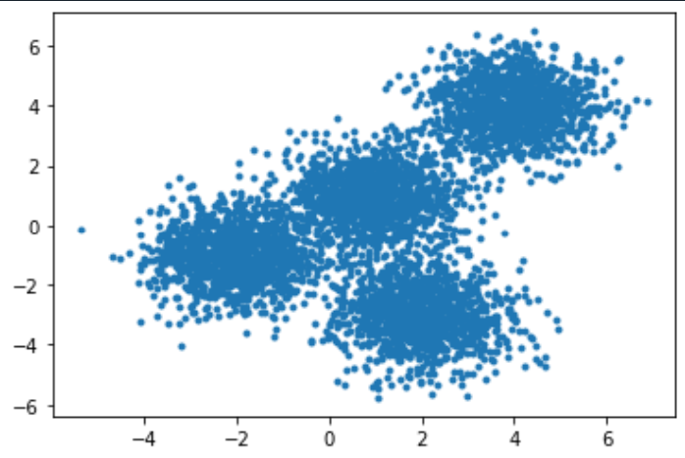
After clustering,the ouput is as follows:
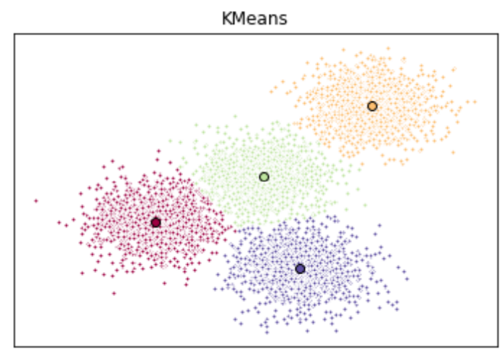

Elbow method:
import pandas as pd
import matplotlib.pyplot as plt
import seaborn as sns
sns.set()
from sklearn.cluster import KMeans
data = pd.read_csv('Countryclusters.csv')
plt.scatter(data['Longitude'],data['Latitude'])
plt.xlim(-180,180)
plt.ylim(-90,90)
plt.show()
x = data.iloc[:,1:3] # 1t for rows and second for columns
wcss=[]
for i in range(1,7):
kmeans = KMeans(i)
kmeans.fit(x)
wcss_iter = kmeans.inertia_
wcss.append(wcss_iter)
number_clusters = range(1,7)
plt.plot(number_clusters,wcss)
plt.title('The Elbow method')
plt.xlabel('Number of clusters')
plt.ylabel('WCSS/variation')
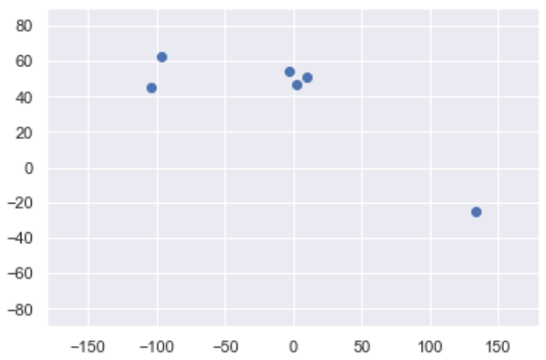
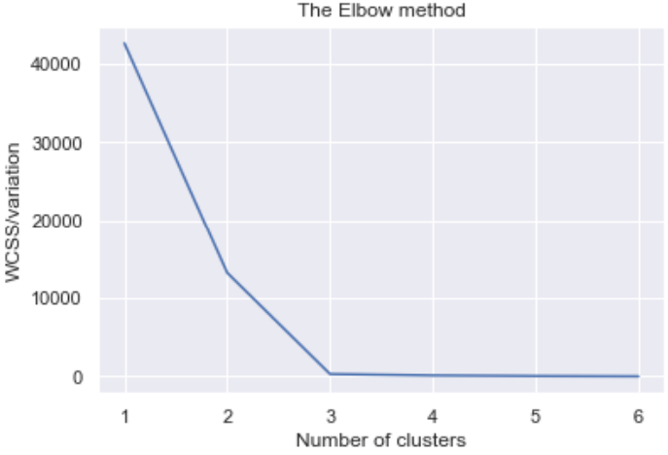

- Conclusion &Future Direction
K- means algorithm basically classifies the given data sets into required number of clusters. So, this algorithm is user friendly and is fast in its implementation. This can be applied to various domains. K-means clustering is one of the most popular clustering algorithms and usually the first thing practitioners apply when solving clustering tasks to get an idea of the structure of the dataset. The goal of k-means is to group data points into distinct non-overlapping subgroups. It does a very good job when the clusters have a kind of spherical shapes.
However, it suffers as the geometric shapes of clusters deviates from spherical shapes. Moreover, it also doesn’t learn the number of clusters from the data and requires it to be pre-defined. To be a good practitioner, it’s good to know the assumptions behind algorithms/methods so that you would have a pretty good idea about the strength and weakness of each method. This will help you decide when to use each method and under what circumstances.

- Reflection Portfolio
K-means algorithm is one of the finest algorithms in clustering tasks performed in data mining. It is tough to perform any technique on large datasets. So, with the k-means clustering algorithm, we can group into clusters based on similarities and features among data sets. Once we get clusters after applying the algorithm, we can easily perform further data mining tasks.
There are various ways in which clustering is performed such as elbow method. In this we have implemented the random set generation implementation and elbow method as well.

References
[1] https://www.javatpoint.com/k-means-clustering-algorithm-in-machine-learning

[2] https://www.thefreestudy.com/pdf-data-mining-the-textbook/

[3]https://www.analyticsvidhya.com/blog/2021/11/understanding-k-means-clustering-in-machine-learningwith-examples/

